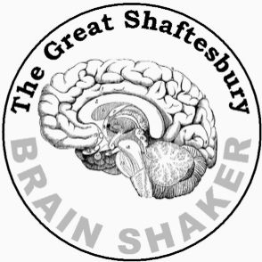
MARATHON ROUND 2
What a Character - Answers
 |  | Character | Author
 | ROO PIT | POIROT | AGATHA CHRISTIE
 | BIG ARSE | BIG EARS | ENID BLYTON
 | GO BIRT HERB | BIG BROTHER | GEORGE ORWELL
 | PAY THE ROTRR | HARRY POTTER | J K ROWLING
 | I TELL LENTL | LITTLE NELL | CHARLES DICKENS
 | BLOBI GIN BAGS | BILBO BAGGINS | J R R TOLKIEN
 | SORE WAY TM | TOM SAWYER | MARK TWAIN
 | OIL RAG BAKE | GABRIEL OAK | THOMAS HARDY
 | POOH IN THE WINE | WINNIE THE POOH | A A MILNE
 | CLAY HARD TETLEY | LADY CHATTERLEY | D H LAWRENCE

